To add a new job assignment to an account first access your Administrator Dashboard.

- Click the Users tab. You can then type in the name of yourself or the learner who you wish to apply the job assignment to into the “Users Fullname” box. Then click the Search button:

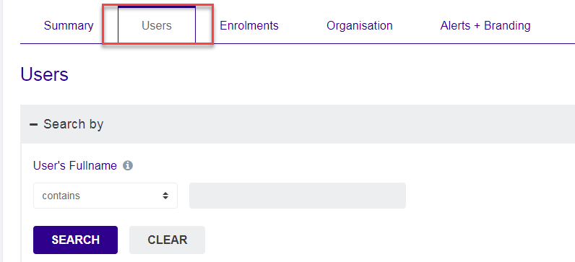

- The account you were searching for will be shown. Click Add/Edit Position under the Actions column.

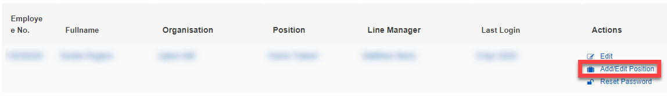

- The Job Assignments screen is then displayed. Click the “Add Additional Position and Organisation” button:

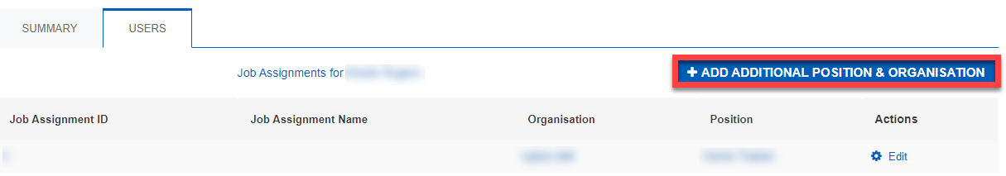

- Enter the following in the “Job Title” and “Job ID Number” fields:

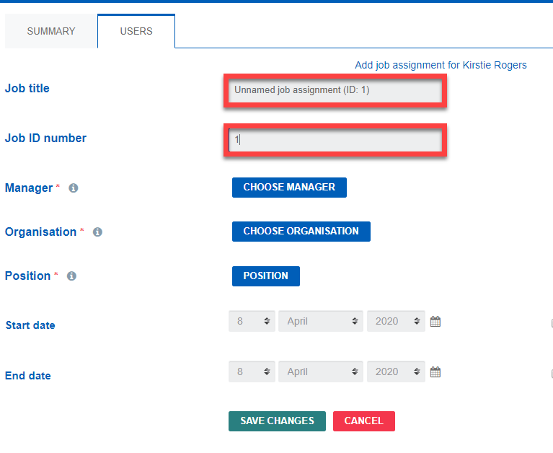

- Click the Choose Manager button and Search for your manager, select them and then click OK.

- Click the Choose Organisation button and search for your other location and select this to add it as your organisation, click OK.

- Click Position and set your position i.e. Home Trainer and click OK

- Click save changes. This will add the new job assignment to the account. Please note this can take up to an hour to appear in the account.

