Getting Started Guide – LearnSpace Admin User

Once you have logged into LearnSpace you will be presented with your main screen, this is your LearnSpace dashboard.

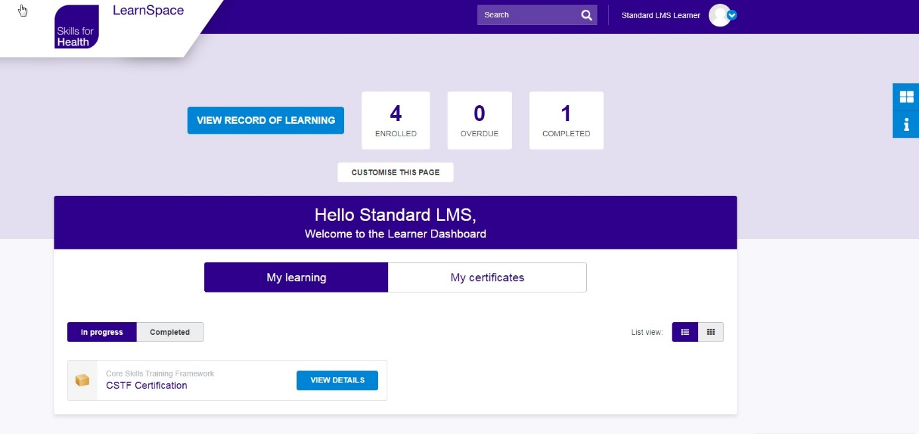
Administrator Dashboard
To access the admin features on the site, click the “switch dashboard” icon located on the right of the screen, just above the “i” icon.

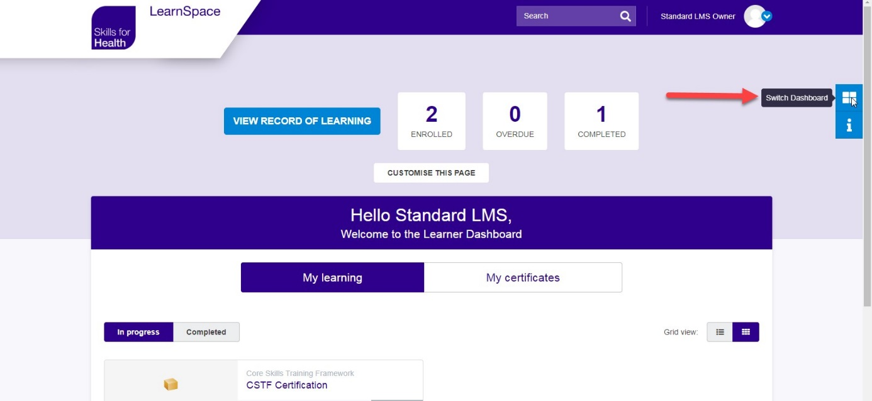

Select “Administrator Dashboard” from the pop-up list.

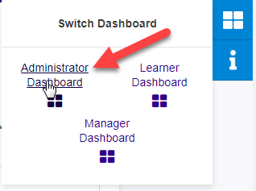

Adding users
From the Administrator Dashboard you will be able to add users, amend their information, view user details and run reports from the users tab.

Manual upload

To manually add users, select the Users tab and click the “Add User” button.

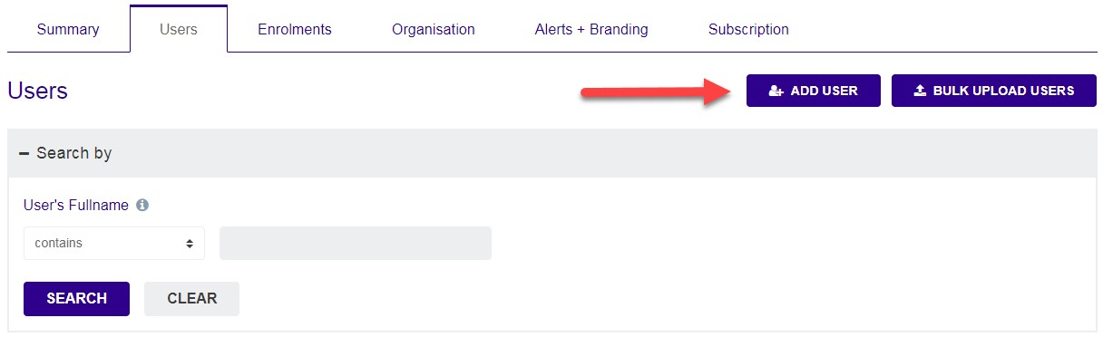

Fill in the details of the user within the form.

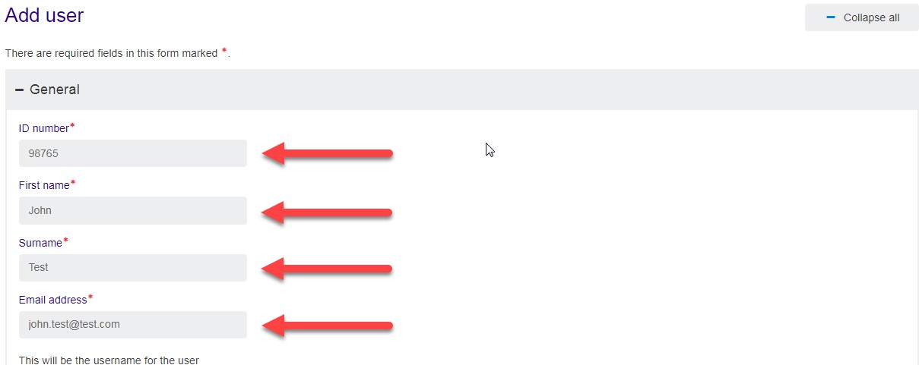

You can then choose for an auto generated password to be sent to the user, or manually create your own and force this to be changed on first log in by ticking the “Force password change” box

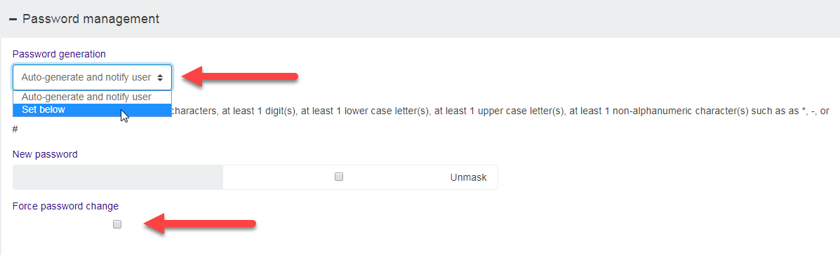

You can then assign yourself as a manager to this user by ticking the "Assign me as manager" box.

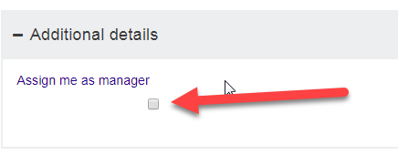

To create the user click the “Save changes” button.

The user will now be shown in your users list.

Bulk Upload
To Bulk upload users click the “Bulk upload users” button.
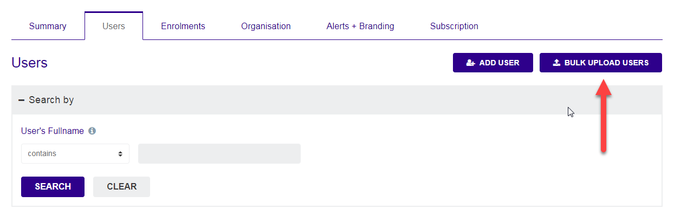

Drag and drop your Bulk Upload file into the drop box or select your file by clicking “Choose a file”. Click “Save Changes” to add these users.
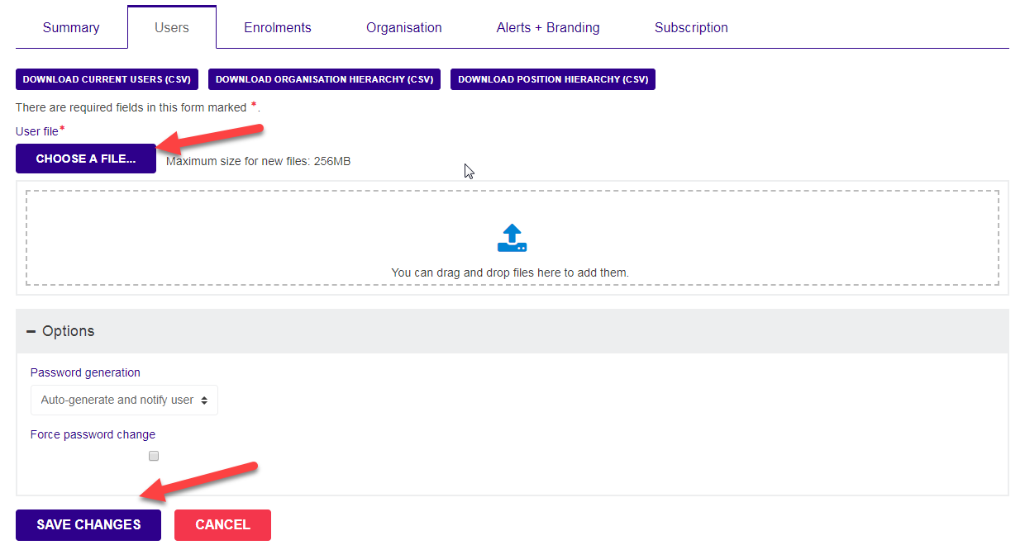

With this option you can also select whether to Auto generate a password for the users or use one set within the file by selecting the correct password generation option. 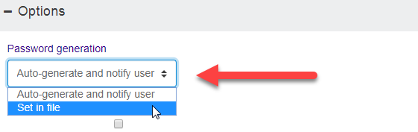
Amending User Details
Within the user screen you can amend a user’s details by selecting “Edit” on the user you wish to amend.

Amend the details you wish to change and then click “Save Changes” to confirm.
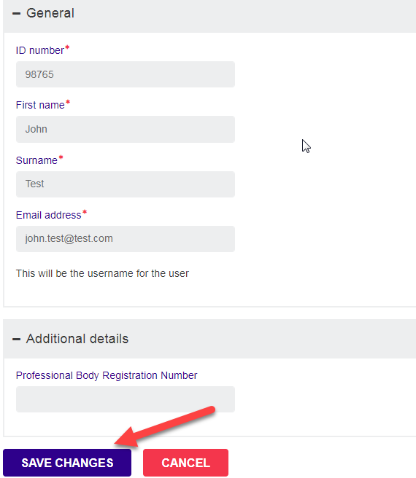

An auto-generated password reset can be sent out by clicking the “Reset Password” button.
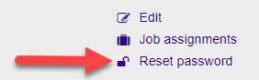

Assigning Courses to Users

You will be able to assign users to courses within the Enrolments tab.

To assign users to courses, under the Enrollments menu, select the Accreditations tab click the Assignments button under the Actions column on the specific course you wish to assign users to.

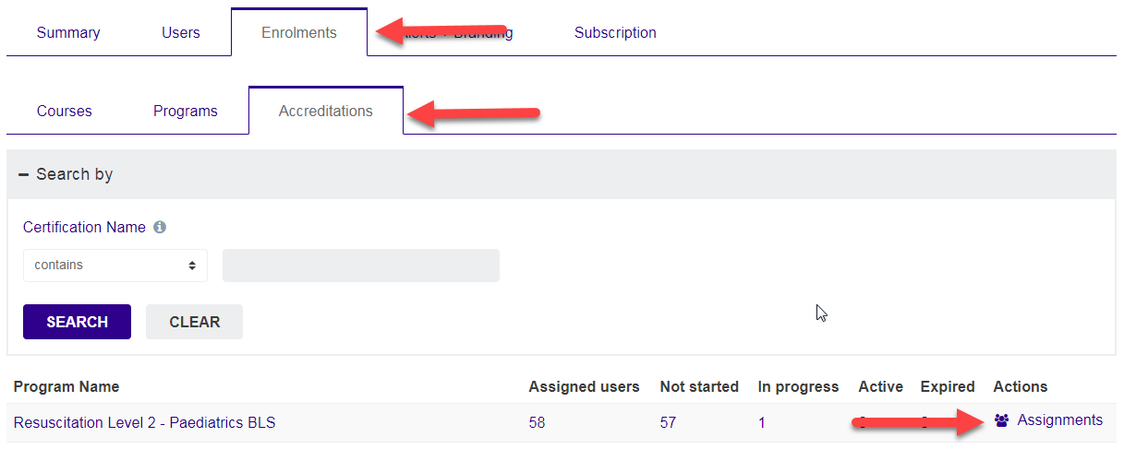

Click the Add Individuals button.

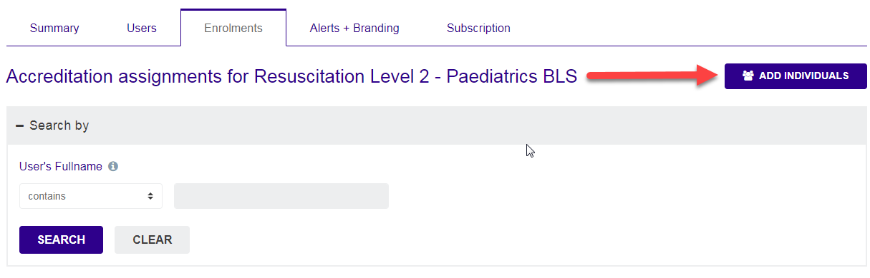

On the next screen yoou can search for the user(s) you wish to assign within the search box, select the name(s) of the users you wish to assign within the users box and click add.

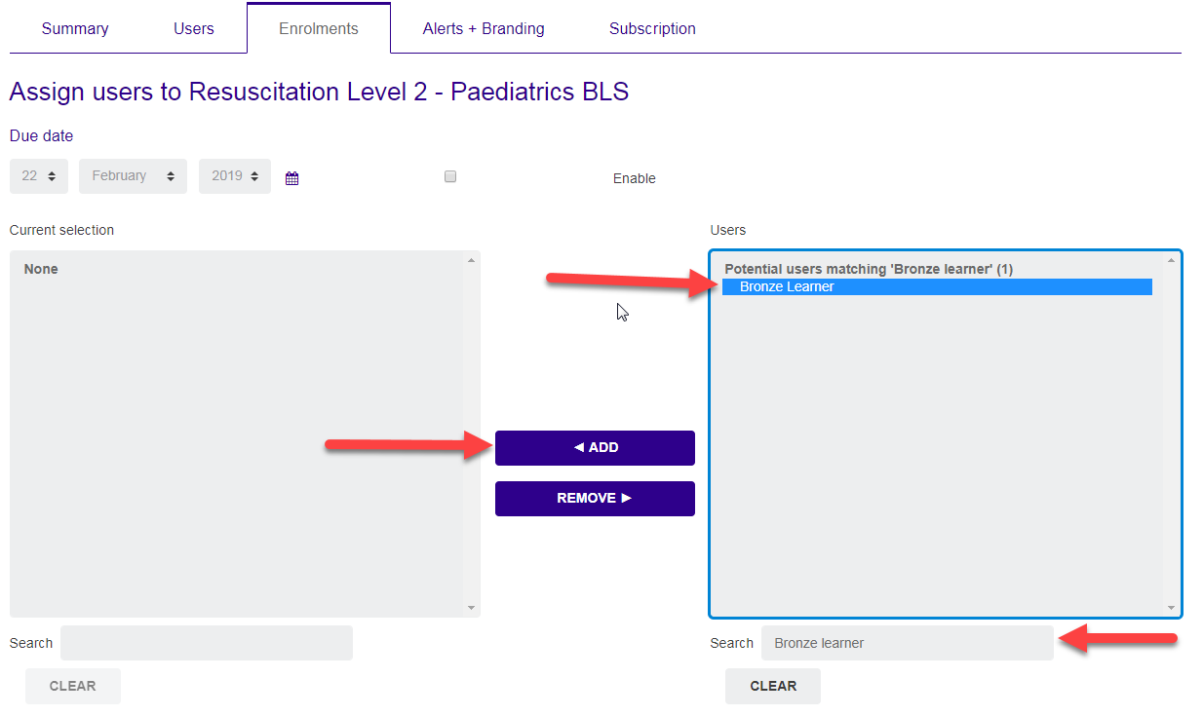

When the selected user(s) show up in the current selection box, select them and click Assign Users to add the users.

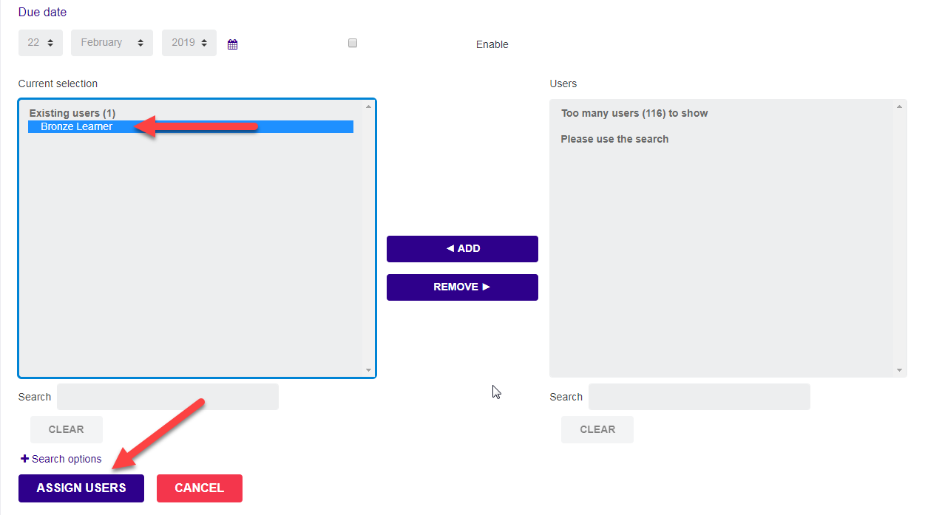
You will then be asked to confirm your selection, click “Continue” to confirm and assign this course to the users.

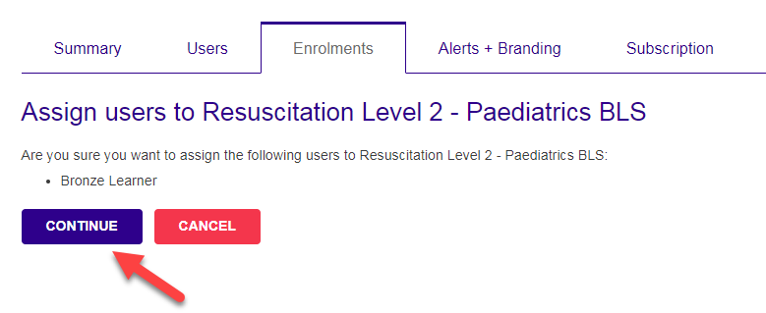

The user(s) will then have access to the course assigned to them.

Viewing user’ progress
On the Users tab, to view a user’s progress click on the records button under the user’s name.

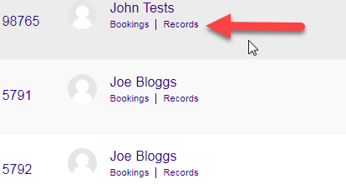

On the next page you will be able to see the courses the user is assigned to, be able to search for specific courses within the search box and see their progress at a quick glance as a percentage with the “Progress” column for each course.

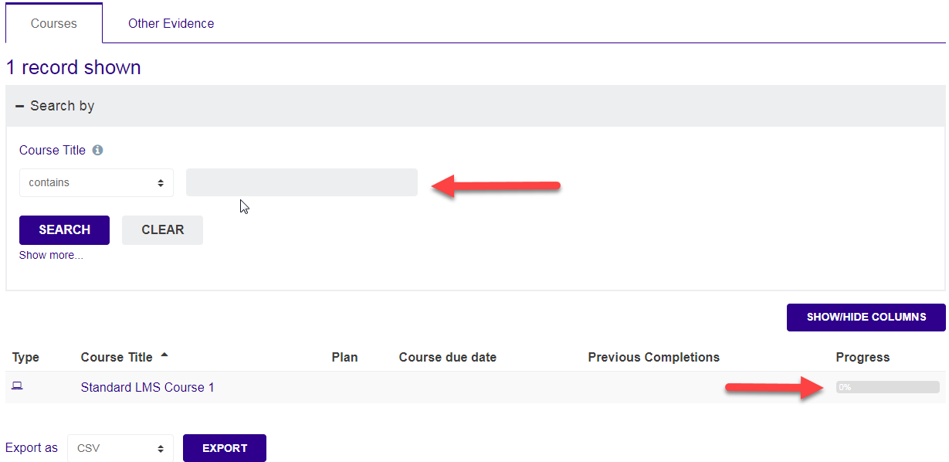

Running reports
To run a report to see all of your users’ progress, select the file type you would like to save the report as and click the “Export” button.
