In order for a Learner to appear under the My Team tab in your Managers Dashboard you will need to assign yourself as the Learners manager within your Tenant Administrators Dashboard.

Login to LearnSpace and access your Tenant Administrator Dashboard. Select the Users Tab.

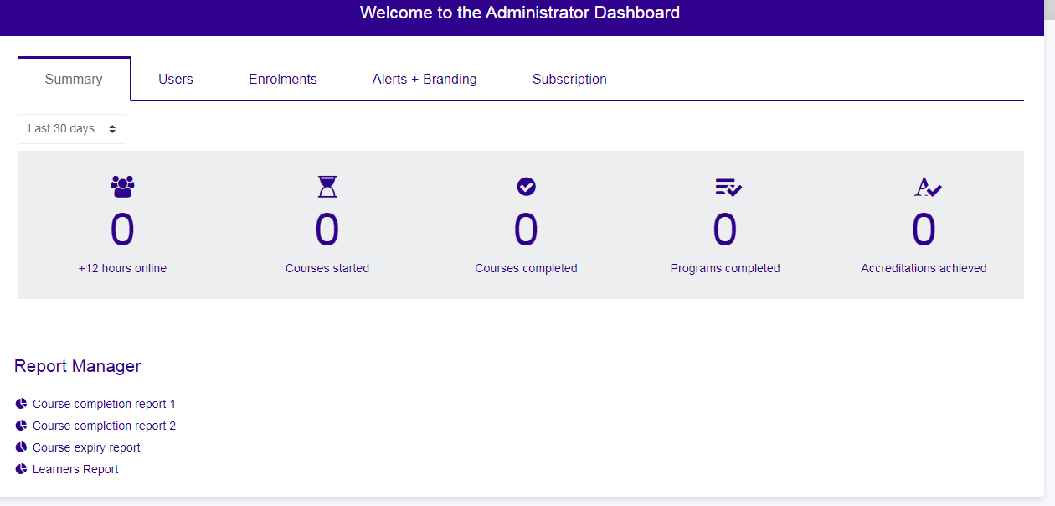

When in the Users tab enter the name of the Learner you wish to appear in the My Team tab into the search box then click the Search button.

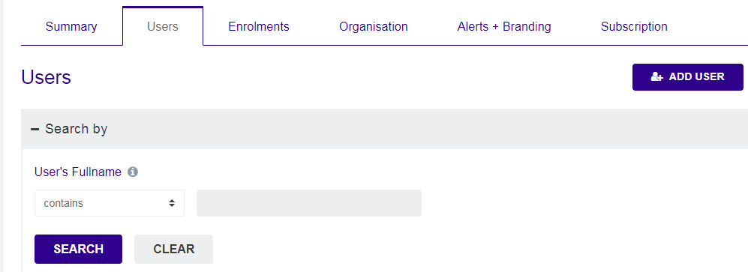

The details of the Learner are listed, you now need to click the Job Assignments option under the Actions column.
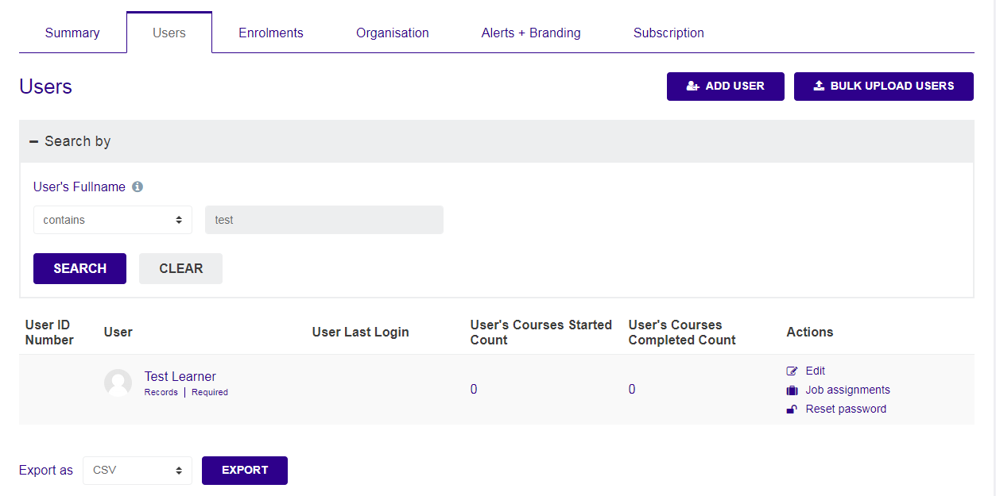
The Job Assignments screen is then displayed. To add yourself as the Learners manager click the Edit option under the Actions column.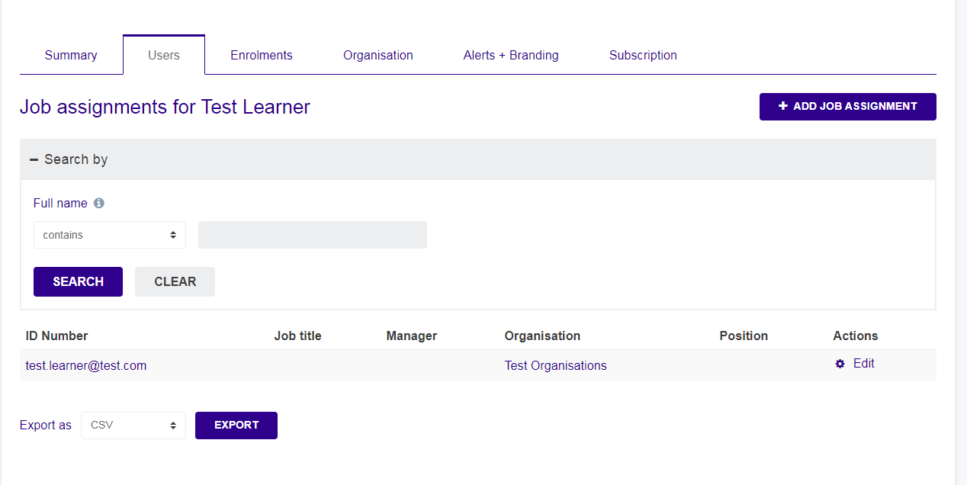

Click the Choose Manager button.

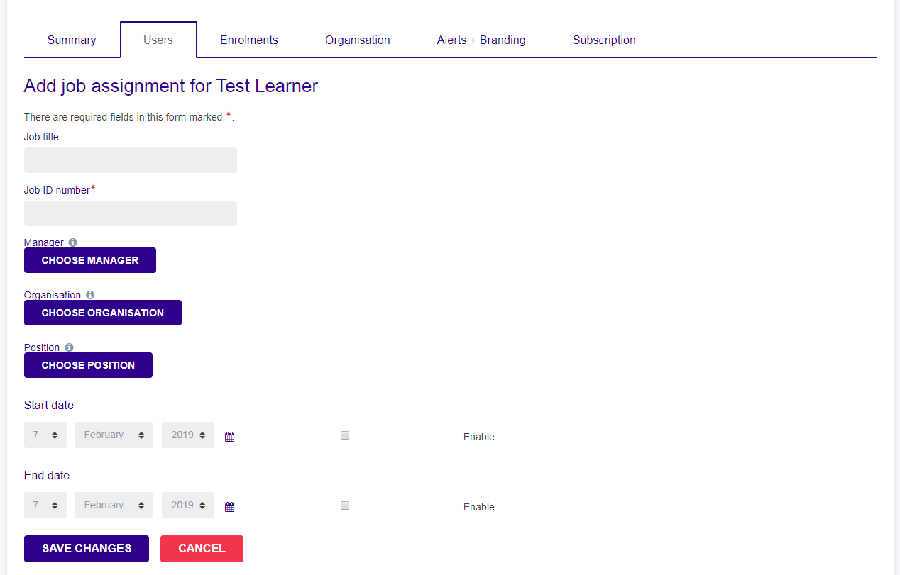

Click the Search tab and enter your name into the search box then click Search.
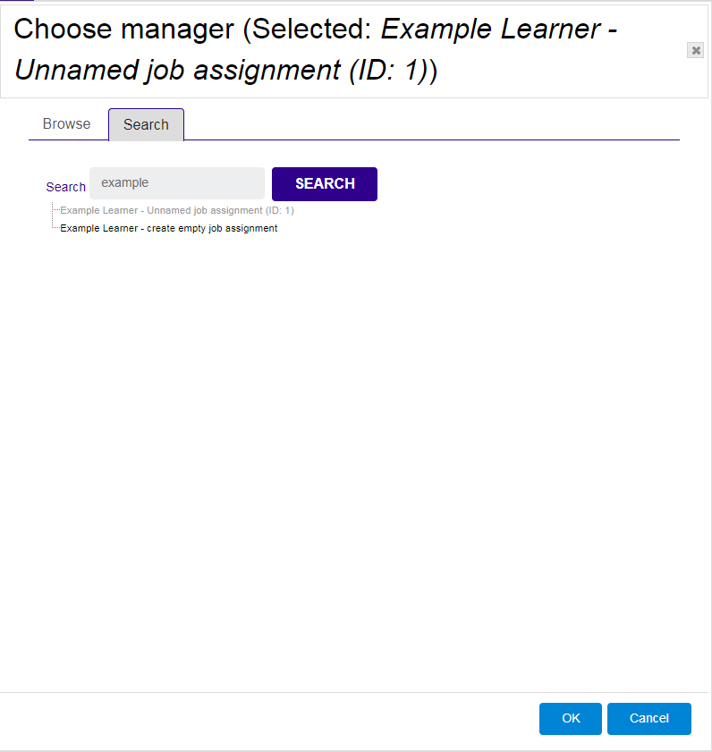
Click your name when its displayed then click ok.
Your name will then be shown next to the Choose Manager button as shown below. To remove yourself as the manager click the red cross.
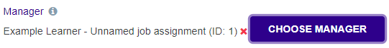
Click the Save Changes Button.

The Learner will now appear under the My Team tab in your Managers Dashboard.

